CSI Gait Dataset Structure

We have collected a robust dataset for wifi CSI based gait recognition. I want to go for a data journal first and then a serious lavel Q1 journal on it. I am sharing the setup details and dataset detail with you.
Technical setup:
01. Intel ax210 as receiver
02. TP-link archer c6 v2 as AP router
03. Picoscense csi tool, data was collected in AP mode
04. Regular router configuration:
There were no modification in the router
05. Modified router configuration:
We detached the 2 of 5GHz antennas from the router and positioned them keeping a gap of almost 4m to get a wide span of walking pattern.

Dataset detail:
01. Total 25 person’s sample were collected with regular router and 5 person’s samples were collected with modified router.
02. For each person we collected 100 samples
03. Each sample has both csi and csv file
04. The odd indexed samples are “left to right” walking samples
05. The even indexed samples are “right to left” walking samples
06. Among them from 1 to 80 samples are normal mood and 81 to 100 samples are with bag mood

Dataset in regular router setup:
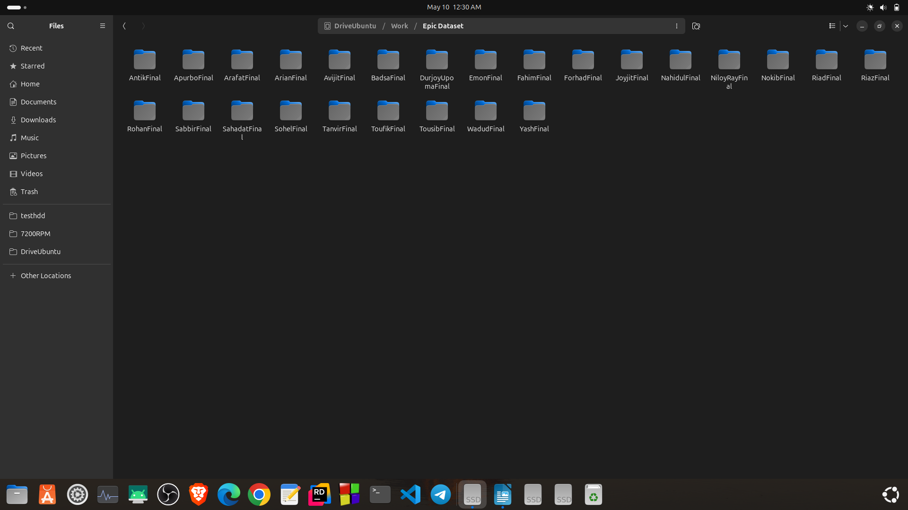


Dataset in modified router setup:
The dataset was collected for the same person in regular router. That means we have 2 version of dataset for the same person one in regular router and other is in modified router.





Have a deep analysis on the dataset

